**1 INTRODUCTION**

**1.1 Overview**

The aim of this project is to build a web App that can automatically select the eligible candidate from the resume send and mail to them as a replay to their application for the job.

Here we use the Pyresparser to sort the resume as selected and rejected by giving the needed skills. As we are using pyresparser we don’t need to create a model it’s provided by pyresparser.

**1.2 Purpose**

Artificial intelligence has made huge inroads into the [human resource](https://analyticsindiamag.com/bringing-simplicity-in-hr-intelligence-the-startup-story-of-goevals/)domain lately. Companies are now deploying [AI tools](https://analyticsindiamag.com/8-fun-ai-tools-available-online/) to reduce or eliminate time-consuming tasks in the recruitment process. According to experts, screening resumes is the most critical, albeit, the most labour-intensive and challenging task for HR personnel.

AI uses machine learning to screen candidates and match their resumes with the job specifications at a blinding speed and stunning accuracy AI uses machine learning to screen candidates and match their resumes with the job specifications at a blinding speed and stunning accuracy

Using pyresparser we automatically select the resume. And then we sent the mail to that candidate from the authenticated gmail account. Using resumeparser we take the name, email address, and skills of the candidate then it check if the skill in the resume matches with the skills in the resume if the skill matches a mail is sent to the candidate that they are selected.

If the skills of the candidate does not matches with the skills we given then the candidate is rejected the name, mail id of the candidate is selected from the resume and a mail is sent that they are not eligible.

We don’t have to manually do the selection process here is done automatically.

**2 LITERATURE SURVEY**

**2.1 Existing problem**

 An HR recruiter of a medium and large corporation gets thousands of job applications. The applications will be all over the map and require hours and hours of screening. And, that’s where AI tools come into play. With the right AI tools, recruiters can sort the applications in a fraction of time.

**2.2 Proposed solution**

As a rule, recruiters receive candidate CVs in PDF or Word formats. It is easy to read the information presented in this manner, however, it is quite difficult to manage, especially if the recruiter receives dozens of new resumes per day.

That is where the resume parsing tool comes into play. Resume parsing solutions frees the recruiter from time-intensive manual CV processing.

**Resume parser** is a tool powered by artificial intelligence that enables recognizing and extracting the necessary information from the CVs in different formats and presenting this data in an organized and understandable manner.

The process starts with uploading all pertinent applicant resumes into the parsing tool. After this, the parser runs through each document, extracts data relevant to both recruiter’s needs and the applications, including information about experience, skills, education, qualifications, and so on.

**3 THEORITICAL ALALYSIS**

**3.1 Block diagram**

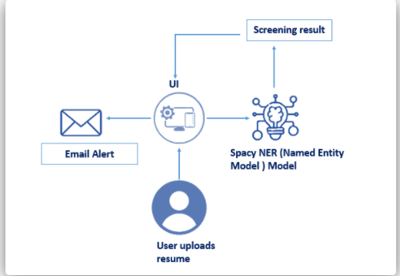

**3.2 Hardware/Software designing**

[Resume Parser](https://www.rchilli.com/documentation/product-docs/resume-parser): helps organizations eliminate the error-prone and time-consuming process and improves recruiters' efficiency.

**Pyresparser**: a simple resume parser used for extracting information from resumes.

**4 EXPERIMENTAL INVESTIGATIONS**

In this web app we are using pyresparser and resume parser so we don’t need to train data or create a model all these are done by the pyresparser. If we upload a resume which matches the silks we mentioned then we will get a mail saying you are selected if we upload a resume which does not match the skill then a rejected mail will be sent.

**4 FLOWCHART**

Interview mail will send

Rejection mail will send

No

Is skills matched

Upload resume

Apply job

**6 RESULT**

This is the home page when we click on apply job it will lead to the next page that is available job there we can see job for AI developer and Java developer we have to choose which one is for us then when we click on apply now. A from gets opened and we have to fill our name and email address then upload the resume then we get a message and email to the email address in the resume contend of the mail will be conforming the interview and if we are note eligible the mail message will be that you are rejected.

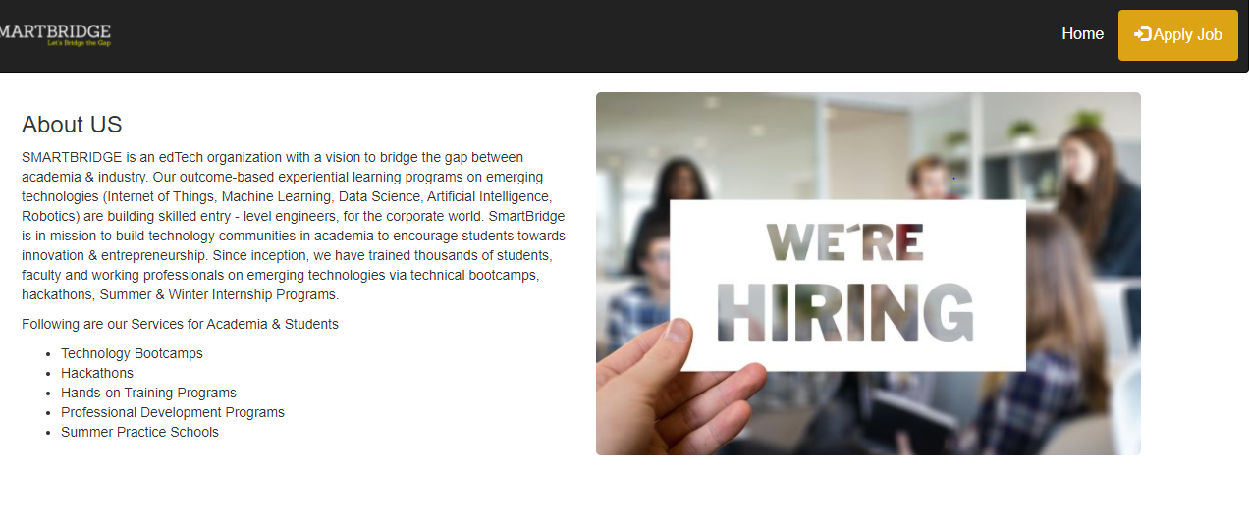

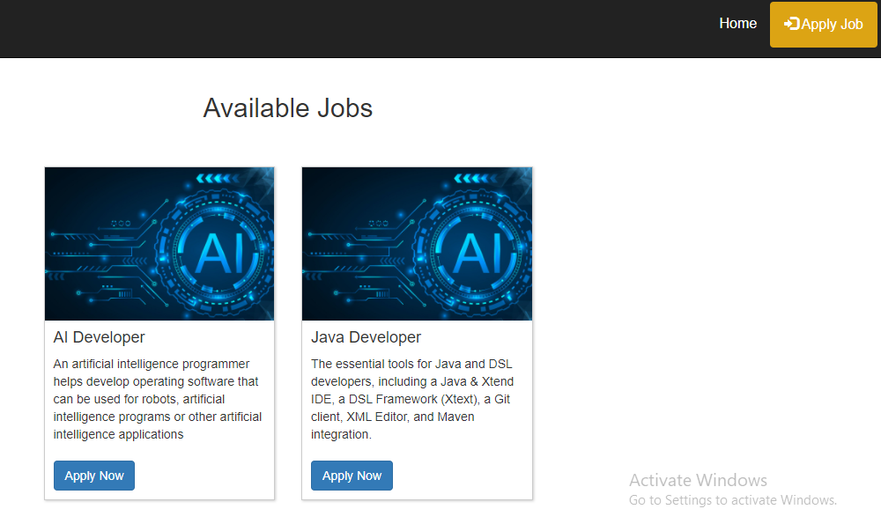

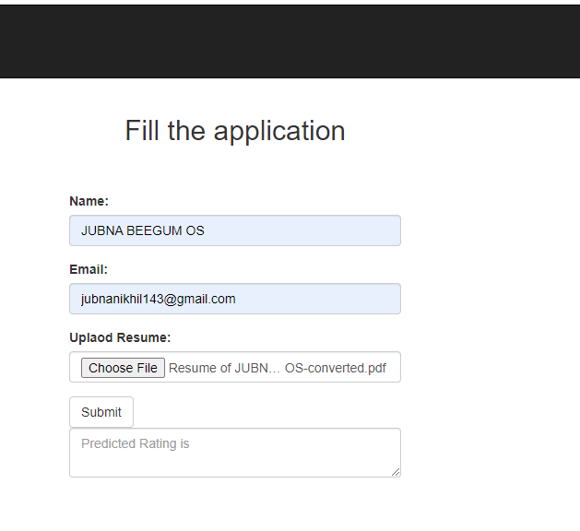

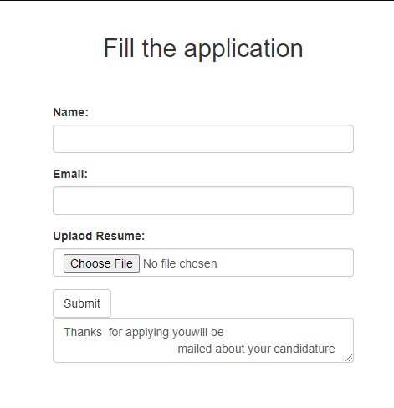

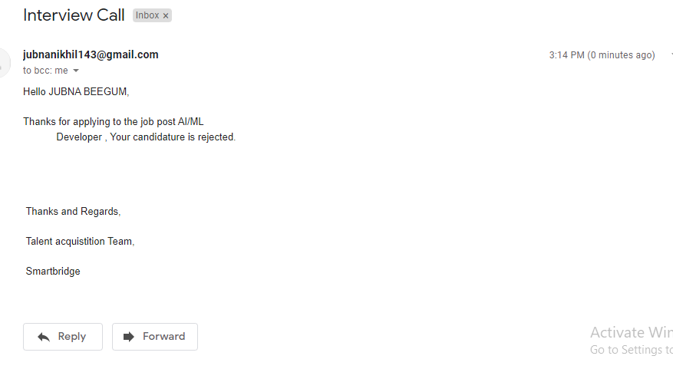

**7 ADVANTAGES & DISADVANTAGES**

**7.1 Advantages**

**It saves time.**Time is precious for a recruiter. It is reported that they spend [an average of six seconds](https://zety.com/blog/hr-statistics#resume-statistics) scanning a resume before rejecting it or deciding to give it a closer look. With the average open position [garnering 250 applicants](https://ideal.com/resume-screening/#:~:text=An%20ATS%20is%20a%20must,has%20some%20well%20known%20weaknesses.), a recruiter could have thousands of resumes to sift through depending on the number of open roles the company has.

**It can help manage a large volume of candidates.** As we stated, the average job posting attracts the attention of approximately 250 applicants. This can often result in an increased risk of human error and carelessness. A recruiter may overlook key qualifications when scanning resumes due to a high volume and a deadline to hire. This can result in missing out on great talent.

Effort and time is saved.

**7.2 Disadvantages**

**False positives and false negatives.** Of course, like anything related to technology, resume screening tools are smart, but they’re not perfect.

While the system can eliminate those who are not a fit, some applicants may [know how to manipulate the algorithm](https://www.pandologic.com/employers/applicant-tracking-system-072016/), resulting in a bad fit landing on the desk of a busy recruiter.

After all, most of the top results for “resume scanner” are written to explain how to game the system.

**8 APPLICATIONS**

To speed up the process, most enterprises have inclined to an automated approach for resume screening to find the right candidates. It comes as no surprise that AI-driven tools for resume screening like Transformify make recruiters' life easy.

**9 CONCLUSION**

Many companies struggle to find the right candidates. In the ongoing battle for talent, artificial intelligence (AI) plays an important role. More and more companies discover that AI can make the recruitment process smarter and more efficient.

Artificial Intelligence (AI) helps companies with predictive analysis to automate recruitment. It does so by matching candidates to the most relevant job profiles with the help of machine learning. ... Machine learning-powered pattern matching. Chatbots to automate interview scheduling

**10 FUTURE SCOPE**

In future AI will schedules interviews flawlessly, screens resumes without a hint of bias and identifies the best candidates in record time.

Recent research predicts that [85% of jobs that will exist in 2030 haven’t yet been invented](http://www.iftf.org/future-now/article-detail/realizing-2030-dell-technologies-research-explores-the-next-era-of-human-machine-partnerships/). So even if technology takes over our current jobs, that could actually lead to other kinds of employment. Imagine a world where the most repetitive, dangerous or administrative tasks will be done by machines, leaving humans free to learn and educate themselves in more challenging, innovative, or exciting work.

While that may still be too far ahead into the future of AI for the recruiting world, it’s possible technology will replace people in certain tasks in the next few years. For example, [scheduling interviews](https://blog.workable.com/halve-your-time-to-interview-with-interview-self-scheduling/) or screening resumes. And that will open the way for you to focus more at what humans truly own: relationship building. This includes [employer branding](https://resources.workable.com/hr-terms/what-is-employer-branding), recruitment marketing, candidate experience, proactive sourcing during events or social media.

**11 BIBLIOGRAPHY**

**APPENDIX**

**(attach the code solution for the problem)**